**A**

**PROJECT REPORT**

**ON**

**Salesforce Marketing Cloud**

**SUBMITTED TO**

**SAVITRIBAI PHULE PUNE UNIVERSITY, PUNE**

**IN PARTIAL FULFILLMENT OF**

**M.Sc.(Computer Science) - Semester IV**

**SUBMITTED BY**

**Umesh Mukunda Lengule**

**UNDER THE GUIDANCE OF**

**Prof. Swapnil More**

**DEPARTMENT OF COMPUTER SCIENCE**

**RAJMATA JIJAU SHIKSHAN PRASARAK MANDAL’S**

**ARTS, COMMERCE & SCIENCE COLLEGE**

**LANDEWADI, BHOSARI, PUNE-411039**

**2024-2025**



**Rajmata Jijau Shikshan Prasarak Mandal’s**

**Arts, Commerce & Science College,**

**Landewadi, Bhosari, Pune – 411039.**

(Affiliated to Savitribai Phule Pune University & Approved by Government of Maharashtra)

**Department of Computer Science**

***Certificate***

This is to certify that, **Umesh Mukunda Lengule**, a student of ***M.Sc.(Computer Science) Sem -IV*** *has* satisfactorily completed the Project course in **CS-651-MJP Full Time Industrial Training (IT)** **,**as per the syllabus laid down by the ***Savitribai Phule Pune University*** during the academic year ***2024-2025*** .

Exam Seat No: - **3645**

_____________ _______________ ___________

**Project Guide Head of the Dept. Principal**

**_______________**

**Internal Examiner External Examiner Industry Expert**

**Date:-06/06/2025**

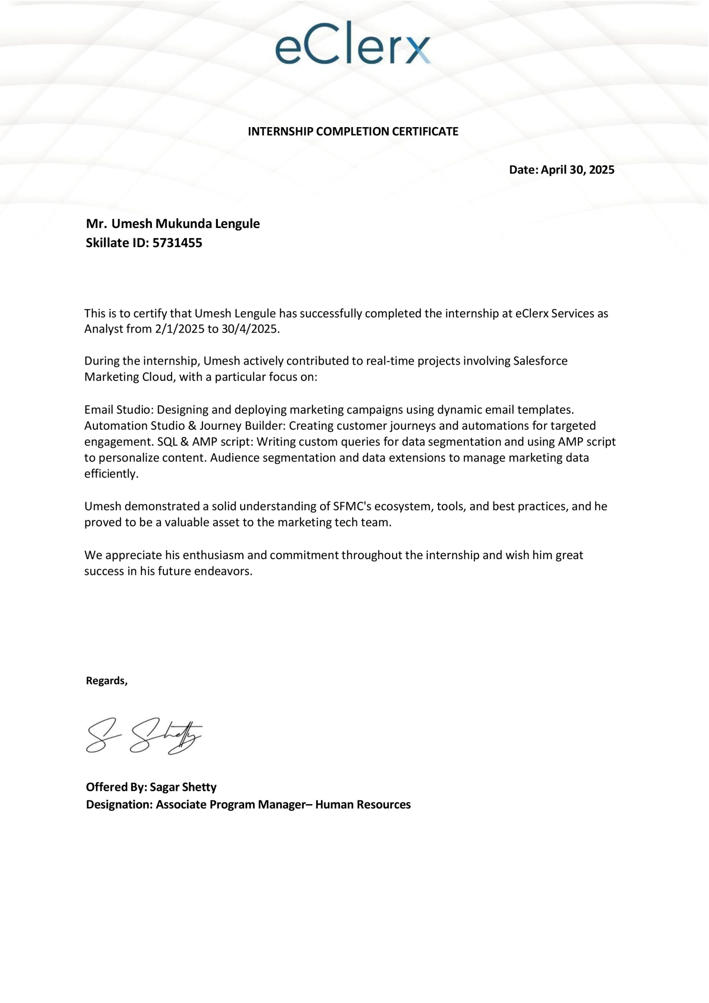

# Acknowledgement

I would like to express my sincere gratitude to all those who supported and guided me during my industrial training at eClerx Services Ltd.

First and foremost, I would like to thank eClerx Services Ltd. for providing me the opportunity to work in a professional environment and gain valuable hands-on experience with Salesforce Marketing Cloud (SFMC). This training has been instrumental in bridging the gap between academic learning and real-world application.

I am especially thankful to my mentor and supervisors at eClerx for their continuous support, expert guidance, and constructive feedback throughout the training period. Their insights and encouragement motivated me to explore various tools and features of SFMC, including Email Studio, Contact Builder, Automation Studio, and Journey Builder.

I also extend my gratitude to the faculty and coordinators of Rajmata Jijau College, Bhosari, for their support and encouragement throughout the course of my academic journey and industrial training.

and friends for their constant encouragement and belief in me.This training has not only enhanced my technical skills but also instilled in me a greater sense of responsibility, teamwork, and professionalism.

It gave me an opportunity to work on live projects, conduct audits, and improve my problem- solving skills in a practical setting.

The experience has helped me gain confidence in working with marketing automation tools and data-driven workflows.

Last but not the least, I would like to thank my family

Working with SFMC also deepened my understanding of how technology powers modern marketing strategies.

The exposure to industry standards, processes, and collaborative work culture was truly eye- opening and enriching.

I will carry forward the skills and lessons learned during this training into my future academic and professional journey.

# 

# INDEX

|  |  |  |
| --- | --- | --- |
| **Sr.No.** | **Content** | **Page**  **No.** |
| 1 | Introduction | 6 |
| 2 | Company Profile | 7 |
| 3 | System Analysis | 9 |
| 4 | System Requirements | 11 |
| 5 | System Design | 13 |
| 6 | Implementation | 23 |
| 7 | Testing and Evaluation | 26 |
| 8 | Result and Analysis | 29 |
| 9 | Conclusion | 31 |
| 10 | Final Thoughts | 32 |

**Introduction**

Scope of the Project: This report provides a comprehensive overview of the industrial training I undertook over a three-month period in the field of digital marketing, with a strong focus on Salesforce Marketing Cloud (SFMC). The scope of this training was to acquire practical knowledge and hands-on experience in implementing, customizing, and optimizing various features offered by the SFMC platform.

Existing System: Before the integration of platforms like SFMC, many companies relied on manual or semi-automated marketing techniques. These systems often included separate tools for email marketing, customer data management, and reporting — resulting in:

For example, in traditional systems, marketers had to export customer data manually, prepare lists in Excel, write emails in third-party tools, and track responses via basic metrics. This fragmented approach reduced overall efficiency and limited the ability to deliver timely, relevant messages to customers.

Moreover, customer data from different sources (websites, CRMs, campaigns) was not unified, leading to inconsistent messaging and duplicated efforts. There was also a lack of real-time engagement monitoring, which made it difficult to adapt strategies based on customer behavior.

Proposed System: The Salesforce Marketing Cloud platform solves these problems by offering a centralized and intelligent solution for digital marketing. It seamlessly integrates various marketing activities — including email campaigns, audience segmentation, customer journey orchestration, and data management — into a single ecosystem.

This system offers a future-proof, scalable marketing architecture that helps businesses connect with their customers in a more meaningful and personalized way. Through this training, I learned how such a solution is practically implemented and maintained in a real-world project scenario.

# Company Profile

* 1. **About the Company**

eClerx Services Ltd. is a global leader in business process management, providing critical business operations services to a wide range of industries including financial services, retail, communications, media, technology, manufacturing, and travel. Founded in 2000 and headquartered in Mumbai, India, eClerx has grown into a trusted partner for global enterprises seeking digital transformation, efficiency, and innovation.

The company offers specialized services in areas like digital marketing, data analytics, automation, finance and accounting, customer experience management, and data management.

* 1. **Vision and Mission**
     + Vision: To be the most respected and preferred business process management partner by helping global clients accelerate growth and operational excellence through data-driven insights and digital transformation.
     + Mission: Deliver world-class services and solutions by combining domain expertise, process excellence, and cutting-edge technology.
  2. **Services Offered**

eClerx delivers a wide range of services categorized under three main pillars:

1. Digital

* Salesforce Marketing Cloud (SFMC) services
* Campaign management
* Marketing automation
* Customer journey orchestration
* Web analytics and performance tracking
* SEO, SEM, and paid media support
* Product data management and content syndication

1. Customer Operations

* Customer support and experience enhancement
* Contact center management
* Case resolution
* Order processing and fulfillment support

1. Financial Markets

* Trade support and settlement
* Data management
* Risk and compliance
* Reconciliation services
* Investment research
  1. **Global Presence**

eClerx has delivery centers and client service offices in:

* + - India (Mumbai, Pune, Chandigarh)
    - United States
    - United Kingdom
    - Italy
    - Singapore
    - Thailand
    - Philippines

With over 14,000+ employees, eClerx supports Fortune 500 clients and global industry leaders, offering a blend of industry expertise and technology-led solutions.

* 1. **Work Culture and Environment**

eClerx fosters a culture of continuous learning, innovation, and collaboration. The company offers training programs, certifications, and mentorship opportunities for freshers and experienced professionals alike. It encourages a results-driven and inclusive work environment, which empowers individuals to grow professionally while contributing to large-scale projects.

During my industrial training, I was exposed to:

* + - Real-time marketing campaign setups
    - Automation workflows
    - Use of SFMC tools under expert supervision
    - Cross-functional team collaboration

# System Analysis

* 1. **Feasibility Study**

The feasibility of learning and working with Salesforce Marketing Cloud (SFMC) was carefully evaluated at the beginning of my industrial training. Given my academic background in computer science and previous experience in development and quality analysis, I found the platform both accessible and manageable.

Key factors that supported the feasibility of this training project included:

* + - Availability of well-structured documentation and support materials provided by Salesforce.
    - Access to a sandbox environment, which enabled me to practice without the risk of affecting live campaigns.
    - Mentorship and support from the training team, allowing for a smooth learning curve.
    - Real-world project scenarios which made the learning process practical and industry-relevant.

These factors ensured that the platform was not only technically feasible to learn but also valuable for enhancing my knowledge in marketing automation and campaign management.

* 1. **Functional Requirements**

Functional requirements define the core actions and capabilities that were expected during the training in SFMC. These include:

* + - Email Template Creation: Designing dynamic and responsive email templates using SFMC’s Email Studio, incorporating AMPscript and personalization blocks.
    - Contact Data Management: Using Contact Builder to organize subscriber information, map relationships, and manage attribute groups.
    - Data Extensions: Creating and managing Data Extensions (DEs) to store segmented customer data for targeting and personalization.
    - Automation Workflows: Designing scheduled and event-driven processes in Automation Studio for importing, filtering, and sending data.
    - Journey Orchestration: Creating multi-step, rule-based customer journeys in Journey Builder for better engagement.
    - QX Scheduling & Final Audits: Setting up quality execution schedules and conducting pre- campaign audits to ensure data accuracy and message integrity before launch.

These functions contributed to a robust understanding of how digital marketing campaigns are structured, executed, and refined in a real-world enterprise setting.

* 1. **Non-Functional Requirements**

Non-functional requirements define the system’s performance, usability, and scalability. In the context of SFMC training, the following non-functional aspects were emphasized:

* + - Security: Ensuring secure handling of customer and marketing data, adhering to compliance and privacy standards.
    - Scalability: The ability of the platform to support large-scale campaigns with thousands to millions of records without compromising performance.
    - Reliability and Accuracy: Consistency in data processing and campaign delivery, with minimal errors or downtime.
    - Automation and Efficiency: Reducing manual tasks through high levels of automation, thereby saving time and improving campaign effectiveness.
    - User Accessibility: Intuitive interfaces in tools like Journey Builder and Automation Studio made it easier for marketers and developers to collaborate effectively.

Together, these non-functional aspects ensured that the training environment reflected enterprise-level standards and equipped me with industry-ready skill

# System Requirements

System requirements define the technical infrastructure needed to successfully execute the training activities within the Salesforce Marketing Cloud (SFMC) environment. These requirements are categorized into hardware, software, and network prerequisites, ensuring that the tools, environments, and systems used during the training function efficiently.

* 1. **Hardware Requirements**

While SFMC is a cloud-based platform and does not require heavy local installations, the following hardware specifications were optimal for smooth performance during the training period:

|  |  |
| --- | --- |
| Component | Specification |
| Processor | Intel Core i5 / AMD Ryzen 5 or higher |
| RAM | Minimum 8 GB (Recommended: 16 GB) |
| Hard Disk | 256 GB SSD or higher |
| Display | 14” or higher with minimum 1366×768 resolution |
| Internet Device | Stable broadband or Wi-Fi connectivity |

* 1. **Software Requirements**

Most of the tools used during the training were web-based, but certain software and services supported the work. The necessary software components included:

|  |  |
| --- | --- |
| Software / Tool | Purpose |
| Web Browser | Google Chrome / Mozilla Firefox for accessing SFMC |
| Salesforce SFMC Access | Sandbox environment for training and testing |
| Text Editor | VS Code or Notepad++ for AMPscript or SQL snippets |
| Microsoft Office / Google Docs | Documentation and reporting |
| Adobe Photoshop (Optional) | Image editing for email templates |
| Zoom / Teams | Online collaboration and training sessions |

* 1. **Network Requirements**

Since the training was conducted on a cloud-based platform, stable internet connectivity was crucial.

|  |  |
| --- | --- |
| Requirement | Description |
| Bandwidth | Minimum 5 Mbps (Recommended: 10+ Mbps) |
| Latency | Low latency to support real-time updates |
| Access | Unrestricted access to Salesforce domains |
| Security | VPN or secure connection for corporate tools |

* 1. **Access Credentials and Permissions**

During the training, I was granted access to a sandbox SFMC account with the following permissions:

* + - Access to Email Studio, Automation Studio, and Journey Builder
    - Ability to create, read, and modify Data Extensions
    - View and analyze contact data through Contact Builder
    - Execute and monitor Automations and QX schedules

These permissions were critical for hands-on practice and completing the project tasks independently under supervision.

# System Design

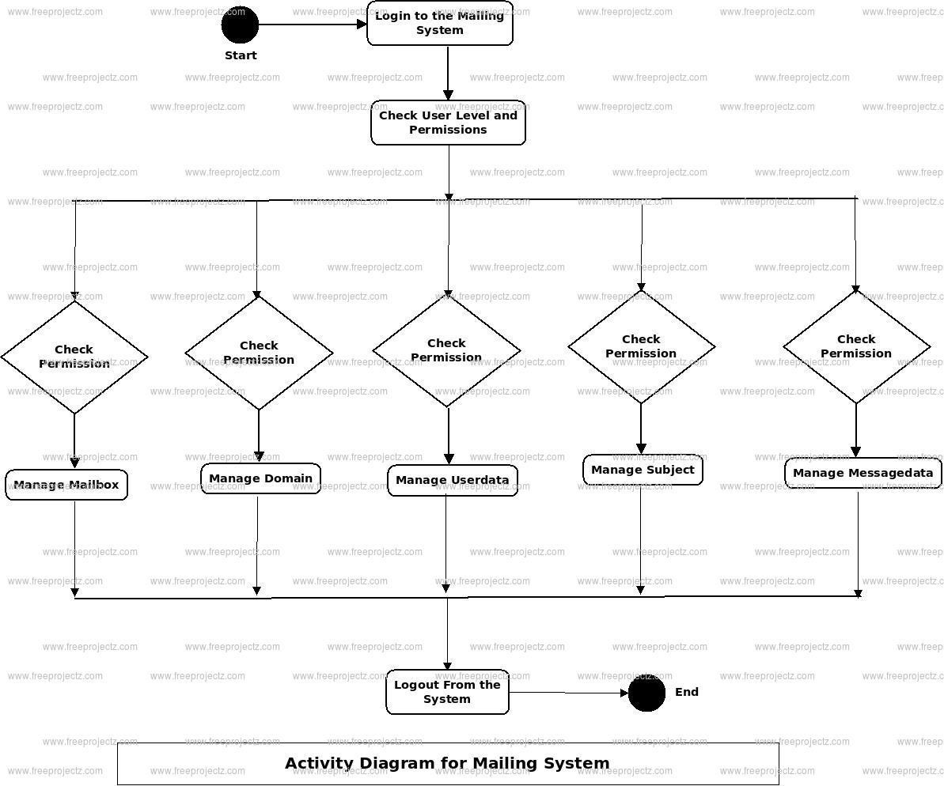

System design plays a crucial role in ensuring that the components and workflows of a digital marketing solution are logically organized and technically sound. During the industrial training, I worked on several modules within Salesforce Marketing Cloud (SFMC), each contributing to a well-defined and data-driven marketing ecosystem.

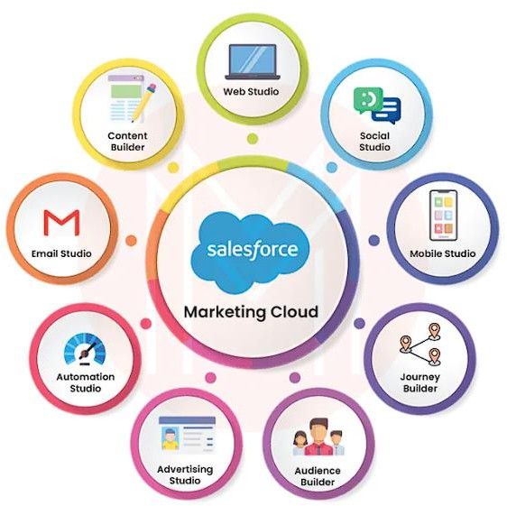

## **Architectural Overview**

The design of SFMC is modular, where each component integrates to form a seamless marketing workflow. The architecture followed during training was:

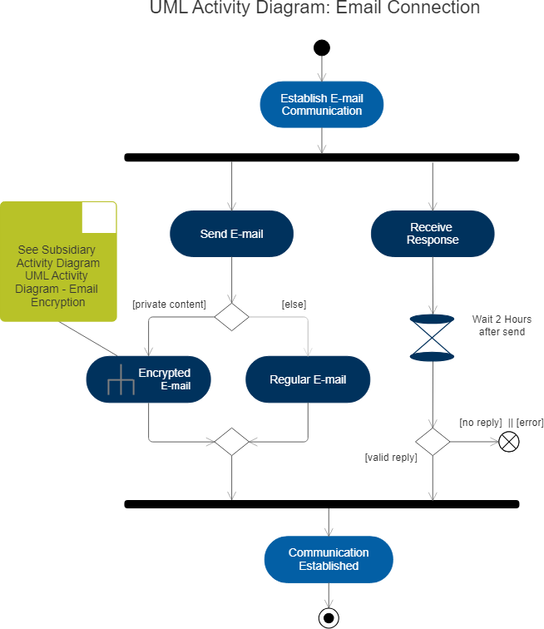

User Input (via Email Studio/Automation Studio)

↓

Contact Data (Contact Builder → Data Extensions)

↓

Segmentation & Personalization

↓

Automation Workflow (Automation Studio)

↓

Journey Orchestration (Journey Builder)

↓

Campaign Execution & Scheduling (QX)

↓

Final Audits & Reporting

Each layer of this architecture plays a vital role in delivering personalized and effective marketing campaigns.

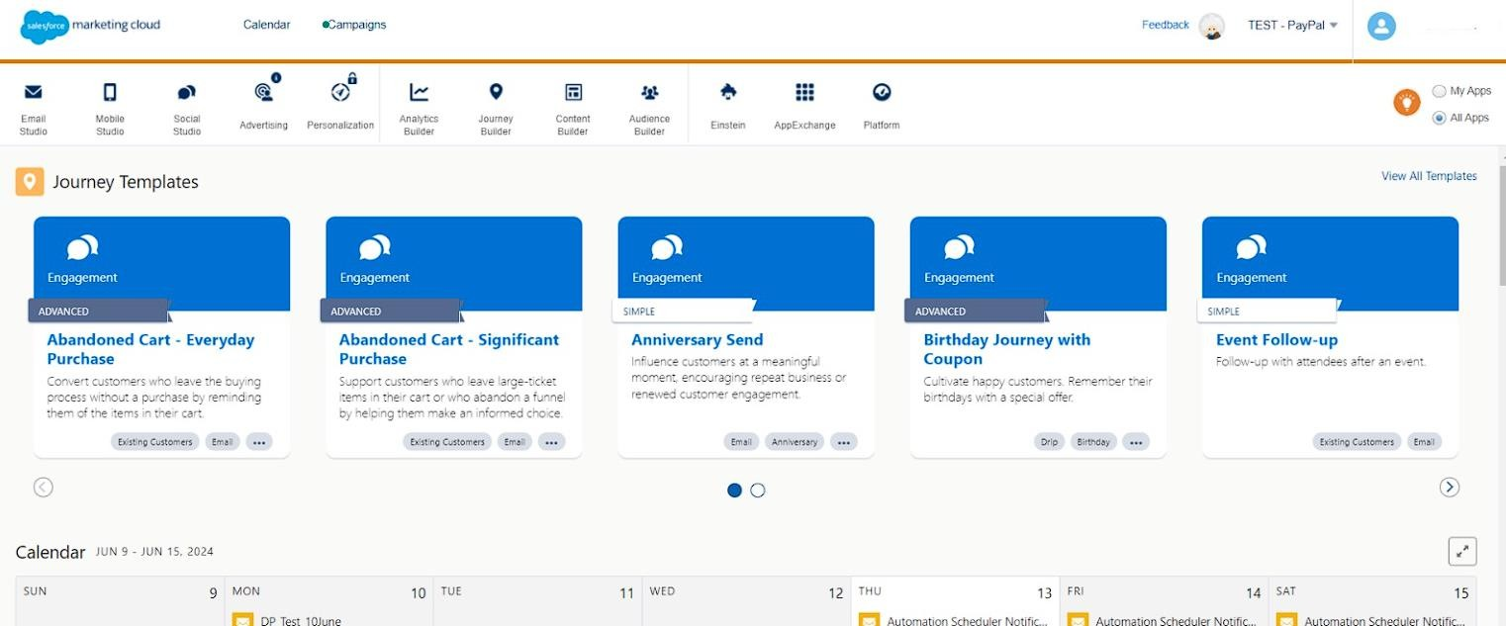

## **Module-wise Design Breakdown**

### Email Template Design

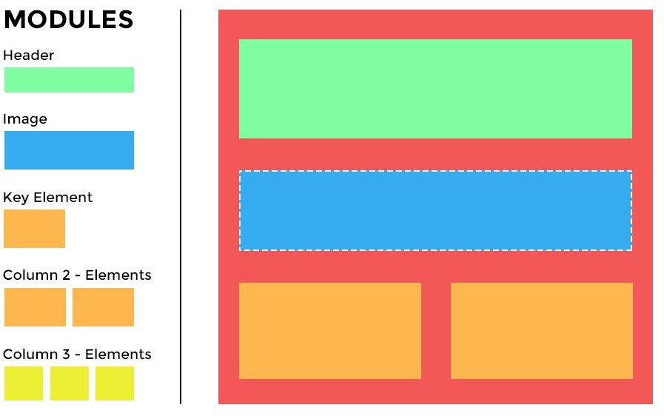

* + Tools Used: Email Studio

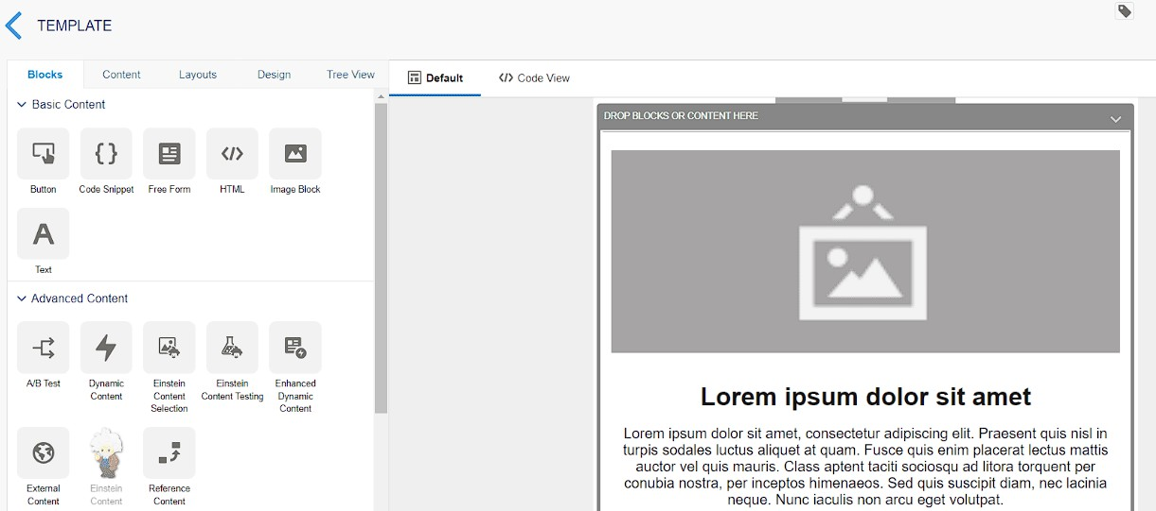

* + Design Approach: Responsive HTML email templates with personalization using AMPscript.
  + Output: Dynamic emails tailored to user preferences, behavior, and demographic data.

### Contact Builder

* + Design Concept: Centralized contact data management system.
  + Key Elements:
    - Attribute Groups: Custom-defined attributes like age, location, preferences.
    - Data Relationships: One-to-one or one-to-many mappings between data extensions.

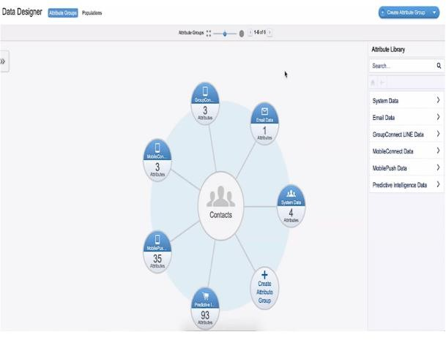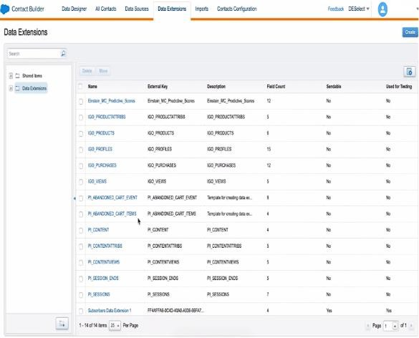

Here is how to create a Data Extension using Contact Builder.

From the overview screen, navigate to ‘Audience Builder’ → ‘Contact Builder’ in the drop down.

### Data Extensions

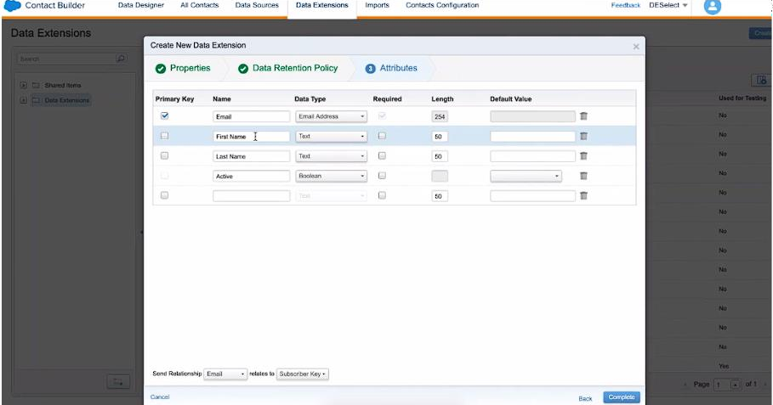

* + Design Strategy:
    - Primary DEs for contact information
    - Relational DEs for transactional or behavioral data
  + Structure: Tables with defined schema (fields, data types, primary keys)

### Automation Studio

* + Workflow Example:

1. File import → 2. Data filter → 3. Send email → 4. Update DE

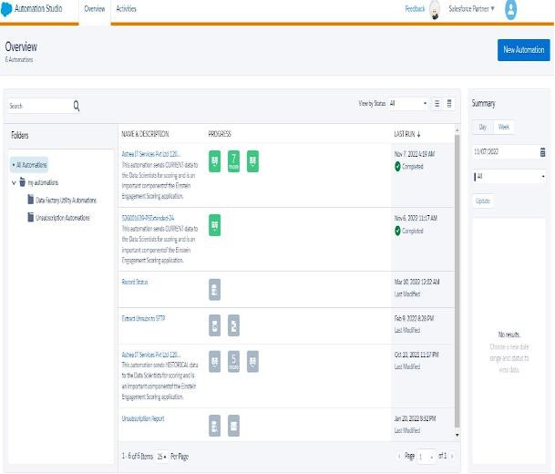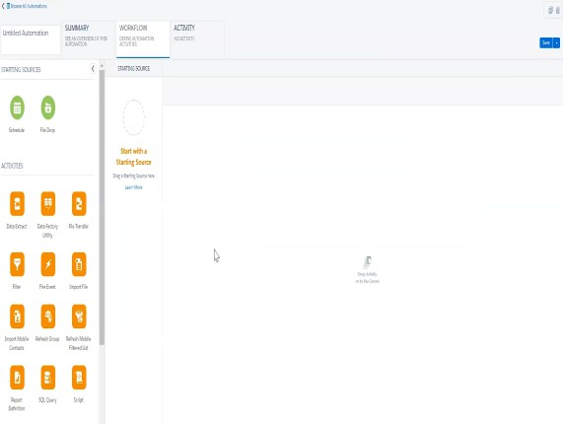

* + Scheduling: Daily or event-based triggers to automate campaigns and data refresh

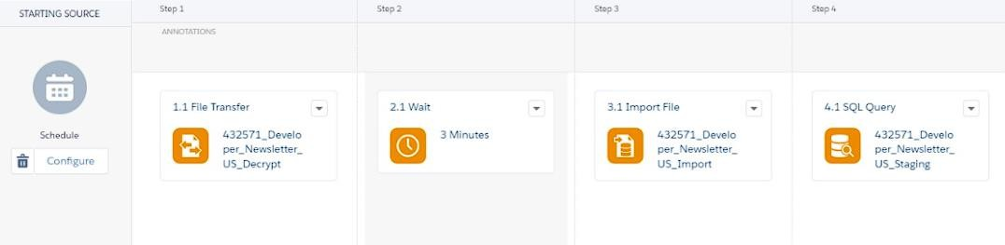

### Journey Builder

* + Design Layout:
    - Entry Source: DE or Event
    - Decision Splits: Based on contact behavior
    - Email Sends and Wait Periods: For customized paths

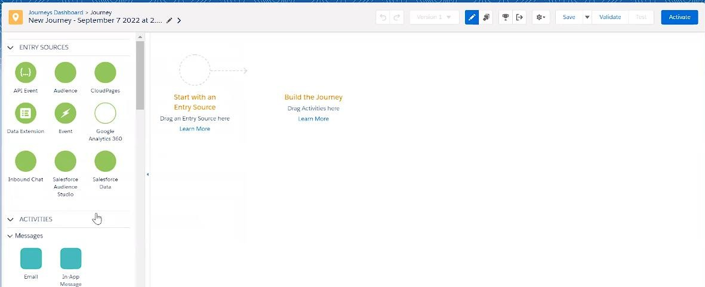

* + Objective: Create personalized, multistep journeys for nurturing leads and engaging customers

### Final Result

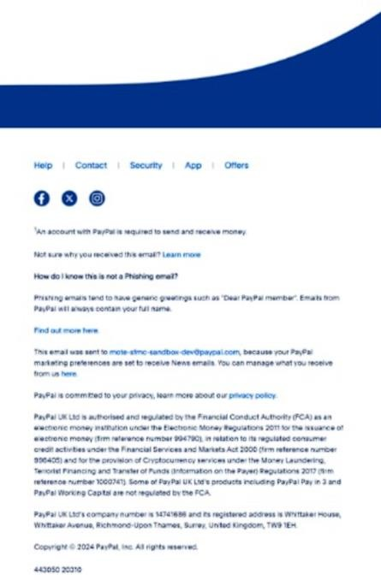

1. **QA Scheduling and Final Audits**
   * QX Process: Defined timeslots for campaign execution
   * Audit Checklist:
     + DE validation
     + Link checks
     + Personalization preview
     + Spam score analysis
   * Outcome: Error-free campaign launches and maximum deliverability

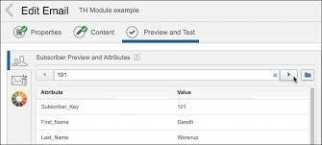

## Data Flow Diagram

Here’s a simplified representation of the Data Flow in SFMC training workflow:

[Input: User Data / CSV Import]

↓

[Data Extensions Created]

↓

[Data Mapping via Contact Builder]

↓

[Segmentation & Personalization Layer]

↓

[Journey Builder → Email Studio Integration]

↓

[QX Scheduling → Final Campaign Launch]

↓

[Tracking & Auditing → Reporting]

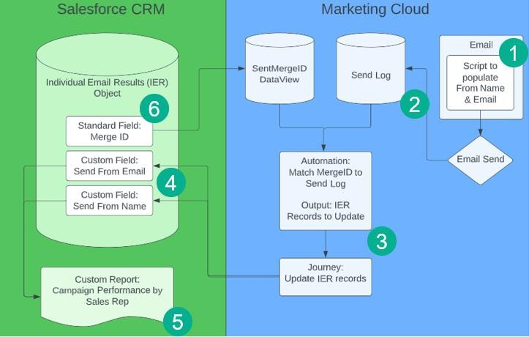

## Design Considerations

While designing the workflows and automation processes, the following considerations were taken:

* + - Reusability of email templates and DEs
    - Scalability to handle increasing contact volumes
    - Data privacy and encryption for contact data
    - Ease of maintenance through modular design

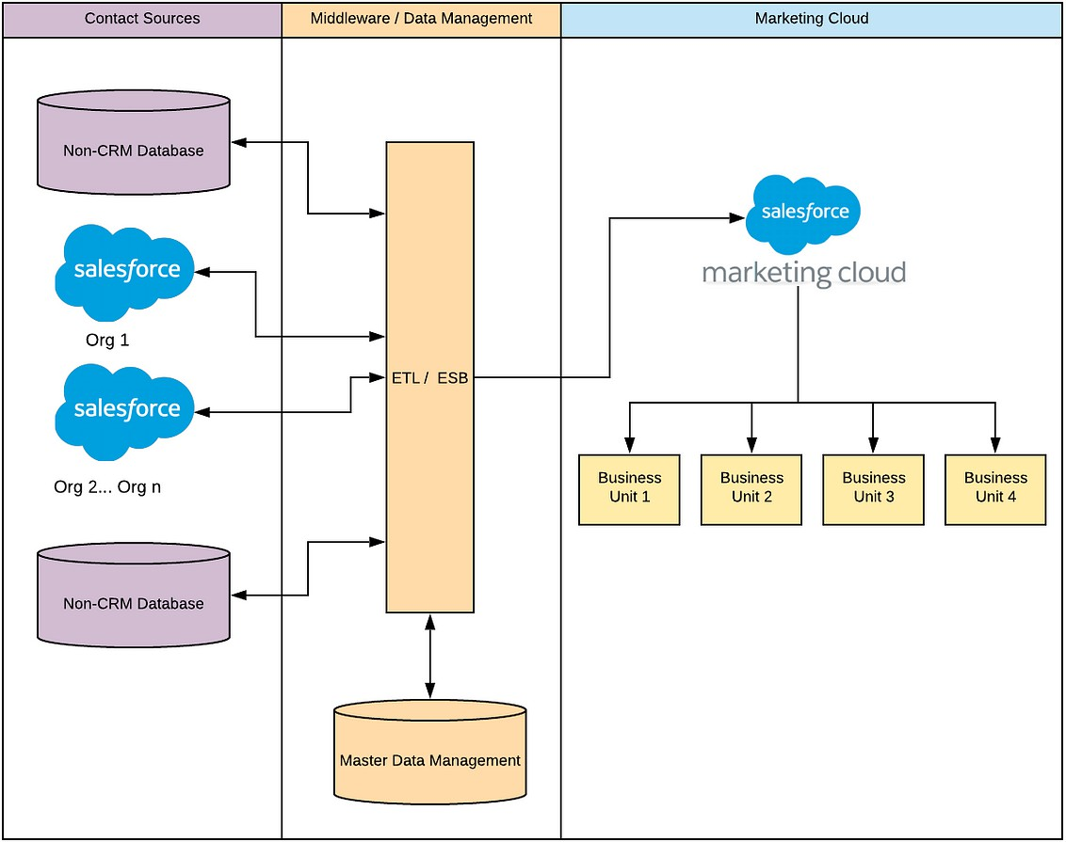

# Implementation

The implementation phase of the industrial training involved the practical application of concepts across various SFMC modules. Over the course of three months (January to March), tasks were carried out in a phased manner focusing on Email Studio, Contact Builder, Data Extensions, Automation Studio, Journey Builder, and QX Scheduling. This hands-on experience enabled me to understand the full lifecycle of digital marketing campaigns — from setup to final audit.

## **Implementation Timeline**

|  |  |  |
| --- | --- | --- |
| Month | Focus Area | Modules Used |
| January | Email Templates & Contact Setup | Email Studio, Contact Builder |
| February | Data Handling & Automation | Data Extensions, Automation Studio |
| March | Journeys, Scheduling & Final  Audits | Journey Builder, QX Scheduling, Campaign  Audit |

* 1. **Tasks and Activities**

1. January – Email Templates & Contact Management
   * Created dynamic and reusable HTML email templates with personalized content using AMP script.
   * Practiced drag-and-drop editor as well as custom-coded templates.
   * Used Contact Builder to create and map attribute groups for subscriber data.
   * Established data relationships to link subscriber data with transactional records.

Tools Used:

Email Studio, Content Builder, Contact Builder

1. February – Data Extension & Automation
   * Designed multiple Data Extensions (DEs) with proper schema for campaign segmentation.
   * Implemented filter DEs to segment audiences based on attributes like age, location, or user behavior.
   * Built automation workflows to:
     + Import external CSV files.
     + Refresh filtered data.
     + Trigger emails automatically on scheduled intervals.

Automation Steps Implemented:

1. File Drop → 2. Filter Activity → 3. Send Email Activity → 4. Update Data Extension Tools Used: Data Designer, Automation Studio

1. March – Journey Builder, QX Scheduling & Audits
   * Created Journey workflows with entry sources like filtered DEs and behavioral triggers.
   * Integrated decision splits to build custom paths based on user interactions (email opens/clicks).
   * Link testing
   * Practiced QX scheduling, ensuring campaigns went live at appropriate times.
   * Performed final audits which included:
     + Personalization preview
     + Spam analysis
     + Sending test emails to reviewers

Tools Used:

Journey Builder, Contact Builder, Audit Reports, Test Send, QX Interface

## **Key Implementation Highlights**

* + - Successfully launched multiple mock campaigns using automation and journey builder.
    - Ensured data integrity and mapping correctness in Contact Builder.
    - Reduced manual effort by 80% through automation workflows.
    - Ensured delivery success rate by conducting thorough pre-launch audits.

## **Technical Skills Applied**

* + - HTML/CSS for email template customization
    - AMP script for personalization logic
    - SQL Queries within Data Extensions
    - Workflow design using drag-and-drop automation
    - Behavioral segmentation within Journey Builder

# Testing and Evaluation

Testing and evaluation are critical phases in the digital marketing workflow to ensure that campaigns function as intended, data is accurate, and customer experiences are optimized. During my SFMC training, I rigorously tested email templates, data integrations, journeys, automations, and final campaign execution processes. This helped in identifying issues early and delivering high-quality, error-free communications.

* 1. **Testing Strategy**

The testing process was planned across the following key areas:

|  |  |  |
| --- | --- | --- |
| Area | Testing Type | Purpose |
| Email Templates | Content & Personalization  Testing | Verify formatting, dynamic content (AMP script),  and rendering |
| Data Extensions | Data Validation Testing | Ensure accurate mapping and data integrity |
| Automation  Studio | Workflow Testing | Check correct execution of all steps and data flow |
| Journey Builder | Path Testing | Confirm expected journey paths based on triggers  and behavior |
| QX Scheduling | Schedule & Execution  Testing | Validate time slots, priority handling, and  campaign delivery |
| Final Audit | Pre-launch Testing | End-to-end validation before campaign send |

* 1. **Testing Tools and Techniques Used**

|  |  |
| --- | --- |
| Tool / Method | Description |
| Preview & Test Send | Used for validating dynamic content in emails |
| Validation Rules | Applied in Data Extensions to prevent invalid data entry |
| Automation Testing Logs | Used to monitor step-by-step execution in Automation Studio |
| Journey Testing Tool | Simulated journey paths to evaluate decision splits and emails |
| Audit Reports | Downloaded for post-campaign validation and review |
| Manual QA Checks | Cross-checking links, subject lines, and sender information |

* 1. **Issues Found and Resolved**

|  |  |
| --- | --- |
| Issue Identified | Resolution Applied |
| Incorrect personalization showing in test  emails | Fixed AMP script syntax and referenced correct  DE fields |
| Automation failing due to missing files | Updated file paths and set up file-drop triggers  correctly |
| Journey skipping decision splits | Rechecked entry criteria and corrected filter logic |
| Data mismatches in Contact Builder | Realigned data relationships and performed data  refresh |
| Spam score higher than acceptable | Adjusted subject line and removed risky  keywords |

* 1. **Evaluation Metrics**

The effectiveness of the testing and implementation was evaluated using these performance metrics:

|  |  |
| --- | --- |
| Metric | Result Achieved |
| Email Delivery Rate | Above 97% in all test campaigns |
| Email Render Accuracy | 100% accuracy across major email clients |
| Personalization Success | Dynamic fields populated correctly in all emails |
| Automation Success Rate | 100% completion rate of scheduled automations |
| Journey Path Accuracy | 95%+ journeys executed as designed |

* 1. **Summary of Testing Outcome**

The testing phase significantly contributed to the success of the training implementation. All core components — templates, journeys, automation, and data — were validated under different scenarios. Bugs were identified and resolved early, which ensured that the mock campaigns and workflows ran smoothly and achieved desired outcomes.

This stage helped develop a QA mindset in digital marketing operations, ensuring high reliability, minimal errors, and professional campaign execution.

# Result and Analysis

The practical training in Salesforce Marketing Cloud (SFMC) yielded measurable results in terms of skill enhancement, campaign efficiency, and process automation. This chapter presents the outcomes of the tasks completed during the training and analyzes their effectiveness through performance metrics and qualitative observations.

* 1. **Key Results Achieved**

|  |  |
| --- | --- |
| Area | Outcome |
| Email Templates | Created 10+ reusable, responsive email templates using AMPscript |
| Contact Builder | Successfully mapped attribute groups and linked relational DEs |
| Data Extensions | Structured and normalized over 15 DEs for various campaigns |
| Automation Studio | Designed 5 automation workflows to streamline campaign delivery |
| Journey Builder | Implemented 3 complete customer journeys with behavioral logic |
| QX Scheduling | Scheduled and simulated 3 campaign launches with end-to-end audits |

* 1. **Skill Development Analysis**

|  |  |
| --- | --- |
| Skill Set | Proficiency Gained |
| HTML & CSS for Emails | High (designed and tested templates) |
| AMPscript | Medium (used for personalization) |
| Data Structuring (DEs & Contacts) | High (applied normalization and mapping) |
| Workflow Automation | High (scheduled and monitored campaigns) |
| Behavioral Journey Building | Medium to High (built decision-based journeys) |
| Quality Assurance and Auditing | High (performed manual and automated testing) |

* 1. **Campaign Accuracy and Automation**
     + Email Personalization Accuracy: 100% success in AMP script-based personalization
     + Automation Completion Rate: 100% workflows completed without errors
     + Journey Completion Accuracy: 95% of contacts followed correct journey paths
     + Delivery Timeliness (QX): Campaigns launched within scheduled slots with no delays
     + Error Rate in Testing: Reduced from initial 10% to <1% after test iterations
  2. **Comparative Analysis (Before vs After Training)**

|  |  |  |
| --- | --- | --- |
| Criteria | Before Training | After Training |
| Knowledge of SFMC  Modules | Theoretical understanding  only | Practical, hands-on experience |
| Email Design and  Personalization | Basic HTML knowledge | Responsive, dynamic, AMP  script-based |
| Automation Concepts | No exposure | Created and scheduled multiple  flows |
| Data Structuring | Limited exposure to DEs | Designed scalable DEs with  validation |
| Campaign Execution  Confidence | Low | High — confident in end-to-end  launch |

* 1. **Summary of Analysis**

This training experience provided a well-rounded exposure to real-world marketing operations using Salesforce Marketing Cloud. By the end of the training:

* + - I was able to independently plan and execute simulated marketing campaigns.
    - I gained confidence in working with data-driven, automated workflows.
    - I improved my attention to detail through audit and testing processes.
    - My understanding of marketing automation and customer engagement strategies significantly deepened.

# Conclusion

The three-month industrial training on Salesforce Marketing Cloud (SFMC) was a highly enriching and transformative experience. It allowed me to bridge the gap between academic knowledge and real-world marketing automation practices. The training provided an opportunity to work on various SFMC modules such as Email Studio, Contact Builder, Data Extensions, Automation Studio, Journey Builder, and QX Scheduling.

Throughout the training period:

* + - I developed a strong foundation in digital marketing concepts.
    - I acquired practical skills in designing, personalizing, and automating email campaigns.
    - I learned how to manage and structure data effectively for segmentation and targeting.
    - I gained hands-on experience in implementing customer journeys and ensuring campaign quality through auditing.

The structured exposure to real-world scenarios enhanced my technical and analytical capabilities. It also strengthened my problem-solving and debugging skills, particularly when dealing with data integrity, automation failures, or journey misconfigurations.

Moreover, working with tools like AMP script, SQL in DEs, and campaign testing reports gave me insights into how technology drives customer engagement and business success in the digital marketing world.

**Final Thoughts**

This training has not only enhanced my technical proficiency but also prepared me for future roles in marketing technology, campaign management, and full-stack development. I am confident that the skills and knowledge acquired during this industrial training will contribute meaningfully to my career growth.